
Subject: Programming with Java
ASSIGNMENT No : 25
TITLE: Write a Java program using the Thread class to create multiple threads and demonstrate their lifecycle.

Name: Avdhoot Mohite Class: CSE A2
PRN: 25070122056 Batch:25-29

Problem Statement
Write a Java program using the Thread class to create multiple threads and demonstrate their lifecycle.

Learning Objectives
To create and manage multiple threads using the Thread class.

Theory
A thread is the smallest unit of execution within a Java program. Multithreading enables multiple tasks to execute concurrently, improving application performance and responsiveness. Java provides the Thread class for creating threads by extending it and overriding the run() method. A thread passes through different lifecycle stages including New, Runnable, Running, Blocked/Waiting, and Terminated. The scheduler manages thread execution based on system resources. Methods such as start(), sleep(), join(), and interrupt() control thread behavior. Multithreading is commonly used in games, web servers, animation, and background processing applications.

Exercise
- Create a program where multiple threads print numbers simultaneously
CODE:

class NumberThread extends Thread {

NumberThread(String name) {
super(name);
}

public void run() {
for (int i = 1; i <= 5; i++) {
System.out.println(getName() + " : " + i);

try {
Thread.sleep(500);
} catch (InterruptedException e) {
Thread.currentThread().interrupt();
return;
}
}
}
}

public class assignment25a {
public static void main(String[] args) {

NumberThread t1 = new NumberThread("Thread 1");
NumberThread t2 = new NumberThread("Thread 2");
NumberThread t3 = new NumberThread("Thread 3");

System.out.println("Threads created.");

t1.start();
t2.start();
t3.start();

try {
t1.join();
t2.join();
t3.join();
} catch (InterruptedException e) {
Thread.currentThread().interrupt();
}

System.out.println("All threads terminated.");
}
}

OUTPUT:
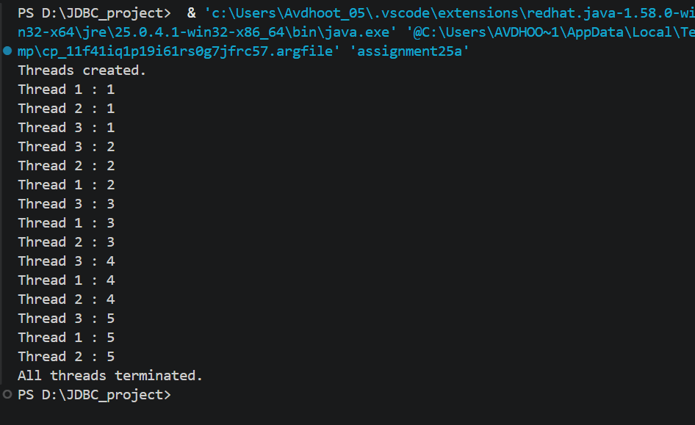
- Create a Java program using multiple threads to simulate bank transactions. One thread performs deposit operations, and another performs withdrawal operations, both printing transaction details simultaneously.

CODE:

class BankAccount {
private int balance = 5000;

synchronized void deposit(int amount) {
balance += amount;
System.out.println("Deposited: Rs. " + amount);
System.out.println("Current Balance: Rs. " + balance);
}

synchronized void withdraw(int amount) {
if (balance >= amount) {
balance -= amount;
System.out.println("Withdrawn: Rs. " + amount);
System.out.println("Current Balance: Rs. " + balance);
} else {
System.out.println("Insufficient Balance!");
}
}

synchronized int getBalance() {
return balance;
}
}

class DepositThread extends Thread {
BankAccount account;

DepositThread(BankAccount account) {
this.account = account;
}

public void run() {
for (int i = 1; i <= 3; i++) {
account.deposit(1000);

try {
Thread.sleep(500);
} catch (InterruptedException e) {
Thread.currentThread().interrupt();
return;
}
}
}
}

class WithdrawThread extends Thread {
BankAccount account;

WithdrawThread(BankAccount account) {
this.account = account;
}

public void run() {
for (int i = 1; i <= 3; i++) {
account.withdraw(500);

try {
Thread.sleep(500);
} catch (InterruptedException e) {
Thread.currentThread().interrupt();
return;
}
}
}
}

public class assignment25b {
public static void main(String[] args) {

BankAccount account = new BankAccount();

DepositThread t1 = new DepositThread(account);
WithdrawThread t2 = new WithdrawThread(account);

System.out.println("Initial Balance: Rs. 5000");

t1.start();
t2.start();

try {
t1.join();
t2.join();
} catch (InterruptedException e) {
Thread.currentThread().interrupt();
return;
}

System.out.println("Final Balance: Rs. " + account.getBalance());
}
}

OUTPUT:
